Network basic course from cisco

Chapter 1🡪

-Internet is not owned by any individuals.

-It’s worldwide collection of interconnected network, cooperation with each other to exchange information using common standards.

-Through: telephone wires, fiber-optical cable, wireless transmission and staleits links.

Local Network:

=SOHO: Small Office/Home Office. Let you share resources like printer, Documents, Pictures and music.

=Server are host have software installed which enable them to provide information.

=ISPS services: Internet services provider cab be local cable provider, a landline telephone services provider. Also provide additional services like: email account, network stage and web host.

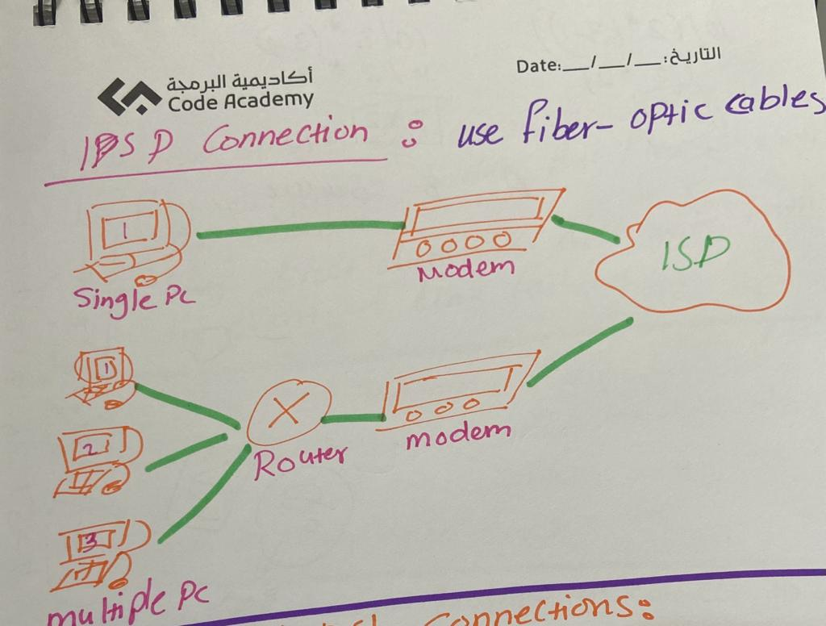

=Cable and DSL connection:

Cable: high bandwidth, always on, connection to internet.

DSL- Digital Subscriber Line: high bandwidth, always on, it’s required a high-speed modern. That separate DSL signal. Allow individual to receive phone call without connecting to network.

2 function of end-devices:

1-They originate the data that flows through the network.

2-They direct data over alternate path in event of link failures.

NFC: near field communication. Is a wireless communication technology that enable data to be exchanged by devices that are in very close proximity to each other.

-If your mobile does not prompt to connect to Wi-Fi network, the network SSID broad cast may be turned off, or device may not be set to connect automatically.

-SSID: is the name of assigned to wireless network.

Home network router: -

-Ethernet Port: connect to the internal switch portion of router.

-Internet Port: used to connect the device to another network. It’s often used to connect to the cable or DSL modem in order to access the internet.

Wired network technology: -

-Ethernet: allow to communicate over wired LAN connection.

-Directly connection devices use an Ethernet patch cable, usually unshielded twisted pair. Parched with RJ-45.

🡪Category 5e cable: most common used in LAN. The cable is made up of 4 Paris of wires that are twisted to reduces electrical interface.

🡪Coaxial Cable: has an inner wired surrounded by a tubular insulating layer that is then surrounded by tubular conducting shield.

🡪Fiber-Optic Cable: can be either glass or plastic with diameter about same hair, it’s can carry digital information at a very high speeds over long distance. Have a very high bandwidth which enable to carry very large amount of data.

Chapter 15 : About TCP and UDP🡪

TCP and UDP ports: Ports are broken into three categories and range in number from 1 to 65,535:

* **Well-Known Ports** - Destination ports that are associated with common network applications are identified as well-known ports. These ports are in the range of 1 to 1023.
* **Registered Ports** - Ports 1024 through 49151 can be used as either source or destination ports. These can be used by organizations to register specific applications such as IM applications.
* **Private Ports** - Ports 49152 through 65535 are often used as source ports. These ports can be used by any application.

Some application are use both UDP and TCP ports Like DNS (Domain Name Server), Some example of ports in TCP and UDP:

Port: 20🡪 TCP 🡪 FTP(File Transfer Protocol) –Data

Port : 21🡪TCP 🡪FTP –Control

Port : 22🡪TCP🡪SSH Secure Shell

Port : 23🡪 TCP 🡪Telnet

Port: 25 🡪TCP🡪SMTP(Simple Mail Transport Protocol )

Port :53 🡪 TCP/UDP🡪 DNS (domain name service )

Port 67🡪UDP🡪 DHCP (Dynamic Host Configuration Protocol) –server

Port: 68 🡪UDP 🡪DHCP –client

Port : 80 🡪TCP 🡪 HTTP

Port : 110 🡪 TCP 🡪 POP 3 (Post Office Protocol Version 3)

Port : 143 🡪 TCP 🡪 IMAP (Internet Message Access Protocol)

Port :161🡪UDP 🡪 SNMP (Simple Network Management protocol)

Port : 443 🡪 TCP 🡪 HTTPS (Hypertext Transfer protocol secure)

-Socket Paris

-by enter **netstat** command it’s will list protocols in use, local address and port number, the foreign address and connection state.

Moudel 16: The client server relationship

There are three common types of service:

1-Mail :-Runs an emails through the server software, It’s use client mail software like Microsoft, outlook

2-Web:- Runs client through server software, It’s use client software like chrome , explore, firfox

3-File:- Windows file Explorer

🡪URI, URN and URL:

URI (Uniform Resource Identifier): String of charestrastic that identifies a specific network source

URN (Uniform Resources Name): to identify a name space of resource (web page, document, Image etc) without refer to protocol.

URL (Uniform Resources Locator): To identify the network location of specific source on the network. HTTP or HTTPS URLs are typically used with web browsers. Other protocols such as FTP, SFTP, SSH, and others can be used as a URL. A URL using SFTP might look like: sftp://sftp.example.com.

These are the parts of a URI, as shown in the figure:

* **Protocol/scheme** - HTTPS or other protocols such as FTP, SFTP, mailto, and NNTP
* **Hostname** - w​ww.example.com
* **Path and file name**- /author/book.html
* 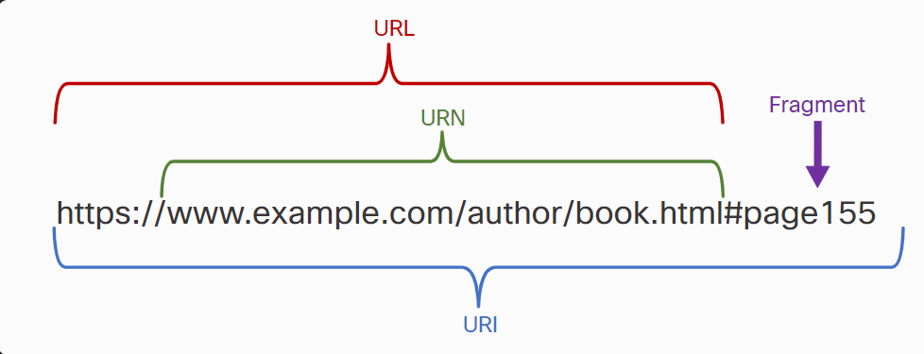**Fragment** - #page155

-Common Network Application server:

1)DNS (Domain Name Server) : Resolve internet names to IP address.

2) SSH (Source Shell): Used to provide remote access to server and network device.

3)SMTP (Simple Maile Transfer Protocols): Send email messages and attachment form client to server and from server to other mail serves.

4) POP (Post Offices Protocols ): Used by email client to retrieve email and attachment from remote server.

5) IMAP (Internet Message Access Protocol): Used by email client to retrieve email and attachment from remote server.

6) DHCP (Dynamic Host Configuration Protocols): Used to automatically configure devices with IP address and other necessary information to enable the to communication over the internet.

7) FTP (File Transfer Protocols): Used interactive file transfer between system.

🡪Talent:

Long before desktop computers with sophisticated graphical interfaces existed, people used text-based systems which were often just display terminals physically attached to a central computer. After networks became available, people needed a way to remotely access the computer systems in the same manner that they did with the directly-attached terminals.

Telnet was developed to meet that need. Telnet dates back to the early 1970s and is among the oldest of the application layer protocols and services in the TCP/IP suite. Telnet provides a standard method of emulating text-based terminal devices over the data network. Both the protocol itself and the client software that implements the protocol are commonly referred to as Telnet. Telnet servers listen for client requests on TCP port 23.

Appropriately enough, a connection using Telnet is called a virtual terminal (vty) session, or connection. Rather than using a physical device to connect to the server, Telnet uses software to create a virtual device that provides the same features of a terminal session with access to the server’s command line interface (CLI).

In the figure, the client has remotely connected to the server via Telnet. The client is now able to execute commands as if it were locally connected to the server.

**Note:** Telnet is not considered to be a secure protocol. SSH should be used in most environments instead of Telnet. Telnet is used in several examples in this course for simplicity of configuration.

Chapter 17: Trouble shooting command:

1. ipconfig – to display the IP configuration information.
2. ping – to test the connection other IP host.
3. netstat – to display the network connections.
4. tracert- to display root taken to destination.
5. nslookup – to Directly queries the name server for information on a destination domain.
6. Ipconfig/all – to display additional configuration like MAC address, IP address of default getaway and DNS server, DHCP server

-🡪 Protocols function:

-DNS: User Request website by typing name.

-Email: A Service that allow workers to send messages to each other over internet.

-File transfer: User upload new file to his or her website.

-DHCP: workstation that give an IP address automatically.

-web server: A user type a URL and page loads in the client browser.

-SSH: Network technician accesses network devices securely from remote sites.

Network Devices and initial configuration

As networks evolve, we have learned that there are four basic characteristics that network architects must address to meet user expectations:

* Fault Tolerance
* Scalability
* Quality of Service (QoS)
* Security

Clouds type:

🡪Public clouds: Public clouds offer cloud-based applications and services to the general public, often utilizing a pay-per-use model or providing free services. They rely on the internet to deliver these services.

🡪Privet clouds: private clouds are designed for a specific organization, such as the government, and can be established using the organization's private network or managed by an external entity with stringent access security.

🡪Hybrid clouds: combine two or more clouds, like a mix of private and public components, connected through a unified architecture. Users on a hybrid cloud can access various services based on their user access rights.

-cloud model represents two or more clouds where each part remains a distinctive object, but both are connected using a single architecture

🡪Community clouds: are exclusively dedicated to a specific community, with tailored functionalities to meet the community's unique needs. For instance, healthcare organizations may use community clouds to comply with regulations like HIPAA, requiring special authentication and confidentiality measures.

-Cloud computing and virtualization: In order to understand the cloud virtualization, It’s important to understand the some of history of server technology.

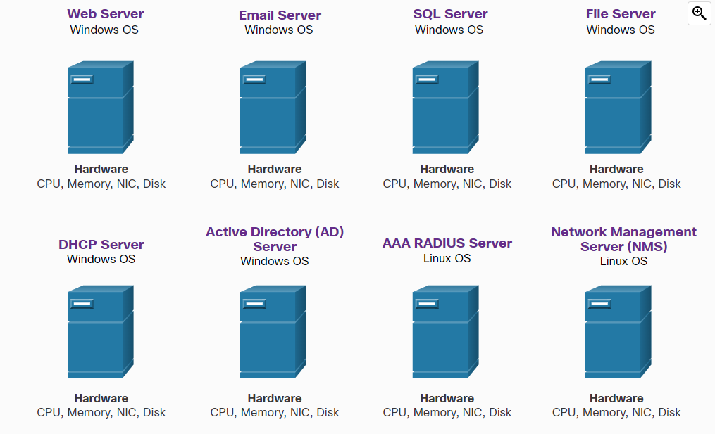

-Advantage of virtualization is overall reduced cost:

1- Less equipment is required: enable server consolidation which required fewer physical devices and lower maintenance cost.

2-Less energy is consumed.

3-Less space is required.

-Additional benefit:

1-Easier prototyping: self-counted lab, operating on isolated network.

2-Faster server provisioning: creating